Questions, I have while studying integration:

1. **How to make Salesforce as Identity provider practically via doing project ?**

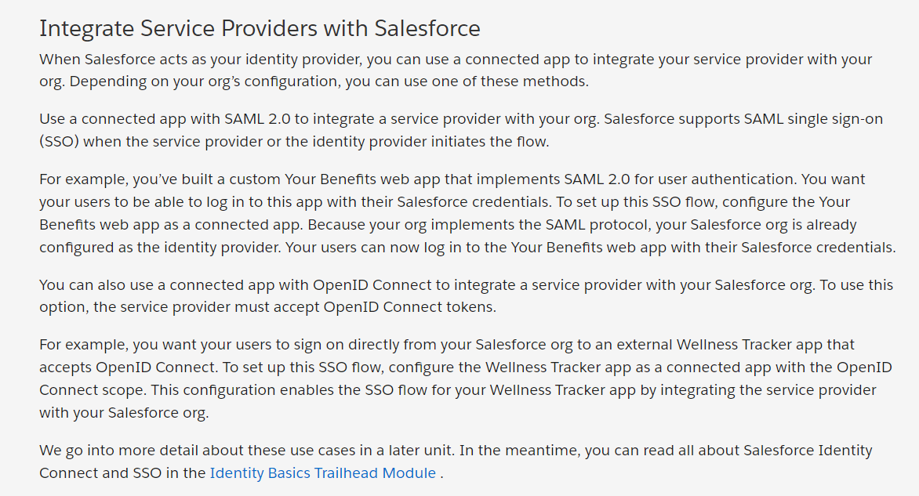

* I was studying Connected App Basics module and Learned about connected Apps chapter. Need to understand this thing practically.

Link: <https://trailhead.salesforce.com/content/learn/modules/connected-app-basics/learn-about-connected-apps?trail_id=build-integrations-using-connected-apps>

* **Need to watch later on YT about openID connect:** <https://youtu.be/0qNQ_YEIM8s?si=0DBoLMMFbEcFzraS>
* **Need to watch later on YT about Salesforce Connected App in details:** [**https://www.youtube.com/watch?v=OCodpKlHOtc&t=110s**](https://www.youtube.com/watch?v=OCodpKlHOtc&t=110s)
* Suggestion while studying about connected app:
  + Need to revise connected App Basics Module on Trailhead